**Cavite State University – Silang Campus**

**Biga 1, Silang Cavite**

**Noirceur Couture, retail E-Commerce system**

*In Partial Fulfilment of the Requirements in*

**DCIT 26 – APPLICATION DEVELOPMENT**

**AND EMERGING TECHNOLOGIES**

*Submitted by:*

**Gatpandan, Nathaniel**

**Salazar, Ana Bien Beatriz G.**

**Eva, Aaron Angelo P.**

BSIT2B

*Submitted to:*

**Mr. Johneros Puyo, MIT**

DCIT26 Instructor

January 24, 2024

**ACKNOWLEDGEMENTS**

We would like to express our sincere gratitude to all those who contributed to the completion of this project. We also acknowledge the support of our friends and family members, who have encouraged us throughout this endeavor. Your unwavering support and encouragement have been constant sources of motivation.

We are thankful to Sir Johneros Puyo, MIT., Instructor in DCIT 26: Application Development and Emerging Technologies. We owe our great experiences and knowledge gained in this research to the guidance that he gave us on this project.

Finally, we would like to thank all the members of our thesis, as well as our classmates and colleagues who were willing to help and teach us to make this project successful.

**TABLE OF CONTENTS**

Abstract ……………………………………………………………………………………………………………………….4

Introduction………………………………………………………………………………………………………….………5

Overall Description………………...………………………………………………………………………….…………6

Online Shopping Website …………………..………………………………….……………………………….……9

Conclusion …………………………………………………………………………….…………………………..……...18

References …………………………………………………………………………….…………………………..……...19

**ABSTRACT**

In today’s rapidly evolving business climate, it is crucial to anticipate client wants accurately and promptly. Clients want to view their business online and have immediate access to the products or services that they offer.

Online Shopping is a lifestyle e-commerce website that sells a range of clothing and lifestyle items. This project allows users to view various goods. accessible allows logged-in customers to purchase chosen products instantly using Cash on Delivery. This project provides administrators and managers with simple access to view-placed orders.

It is essential to learn about the various applications of PHP and MySQL when developing an e-commerce website. An in-depth knowledge of these technologies is required to build a strong online shopping platform. Dynamic webpages can be performed using PHP, a versatile server-side programming language, and MySQL, a common relational database management system, offers an effective data storage option. Developers can develop a multi-tiered architecture that runs an e-commerce website by using PHP's capabilities and integrating it with MySQL's database management functions. The objective of this project is to develop a basic website that provides users with access to a marketplace and supplies things that are tough to find elsewhere, thereby making it simpler for them to shop online. We discovered quite a bit about the technology used to create such a dynamic application by investigating the complexities of PHP, MySQL, and AJAX.

**INTRODUCTION**

E-commerce has become an accepted and utilized business paradigm. Businesses are establishing websites that feature the capability to carry out business transactions in various ways. Thus, it is reasonable to assume that online shopping has become habitual.

With the abbreviation for the exchange of products and services over the Internet, e-commerce involves using Internet platforms and digital technologies to conduct business transactions electronically. Its convenience, accessibility, and global reach have completely changed the way people shop and conduct business. In the early days of the Internet, e-commerce primarily consisted of online retail, in which companies used websites and online marketplaces to sell products directly to customers. However, over time, the diversity of e-commerce has expanded to include a wide range of activities such as digital downloads, online auctions, and business-to-business (B2B) transactions.

The objective of this project is to create a general-purpose online store where consumers can order items such as garments without leaving their homes. However, this study focused on purchasing items online for clothing and accessories retailed from other stores to simplify the implementation.

**Overall Description**

**Description:**

* Anyone can register to look over the products that are available.
* Only members who have registered may purchase any amount of each item.
* In our project, there are three jobs available: Visitor, Buyer, Seller, and Admin.
  + Visitors or non-members can view the products that are available.
  + The buyer can view add to likes and buy any products.
  + The buyer has access to all products that are available and can buy them.
  + An administrator has more privileges, including the same as each visitor and user.
    - Seller and Admin has access to their current and projected revenue.
    - Seller can change product information, add, and remove brands, and add new goods
    - Admin can have multiple stores while seller can only have one.
    - Admin can view, change product information, add, and remove brands, and add new goods of the sellers.
    - Based on the user's delivery information, the seller and admin can send the order to the user.

**Implementing the code:**

* Implement the database with your MySQL server.
* Start Apache and the MySQL module by launching XAMPP. and find the website by putting the entirety of the website's file in the “htdocs” folder.

**Web Pages Details**

* Homepage
* About us section
* Registration Page
* Seller Registration Page
* Log in Page
* My Cart Page
* Check Out Page
  + PayPal checkout Integration
* My Likes Page
* My Orders Page
* My Profile Page
* My Address Page
* My Purchase Page
* **Brand Collections**
  + Brand Items
    - Brand Product
* **Admin page**
  + **Dashboard**
    - View revenue of own admin stores.
  + **Stores**
    - View other stores and stores.
  + **Product page**
    - View other products and add products.
  + **Orders page**
    - Preparing orders page
    - Shipped Out orders page
    - Delivered orders page
    - Cancelled orders page
  + **Users List**
    - Modify & delete users & sellers’ details.
  + **Seller Application**
    - Accept seller application request.
  + **Slideshow**
    - Modify index.php slideshow.
  + **Reports**
    - Print current store reports of admin.
* **Seller page**
  + **Dashboard**
    - View seller revenue.
  + **Your Store**
    - Add & Update store details.
  + **Products**
    - Add and update store products.
  + **Orders**
    - Preparing orders page
    - Shipped Out orders page
    - Delivered orders page
    - Cancelled orders page
  + **Reports**
    - Print seller reports.
  + **Account Details**
    - Update login and pickup address details.

**Online Shopping Website**

Determine Document Minimum Requirements: To begin, determine the specific data that your online retailer needs. Consider various elements that require documentation, such as product details, procedures and guidelines, and technical documentation. This process involves analyzing existing records to identify any gaps or areas that require improvement. Consider other parties involved.

Create a Documentation Plan: Develop a plan for preserving and creating documentation that explains the approaches, rules, and expectations. This includes selecting templates, style guides, tools, and reference forms (such as documents, online assistance). When designing the documentation strategy, consider factors like consistency, usability, accessibility, and scalability.

**HOMEPAGE**: The Home Screen will consist of screen were one can browse through the products which we have on our website.



Figure 1 The Home Page of the website.

**ABOUT US SECTION:** This page describes about website and owners.



Figure 2 The About us of the website.

**REGISTER PAGE**: New buyers can register here.

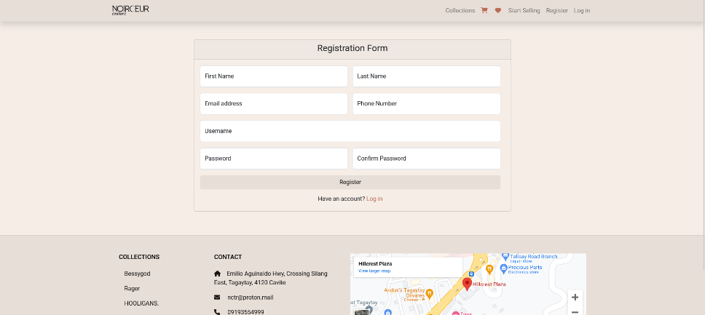

Figure 3A The Register page of the website.

**SELLER REGISTRATION PAGE**: New Sellers can apply an application here.

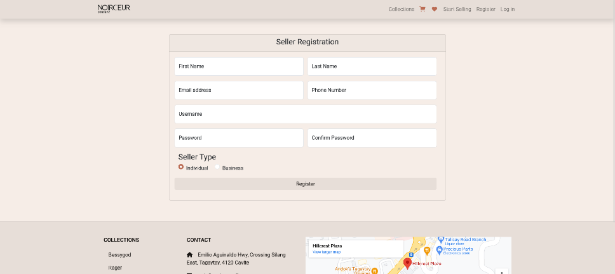

Figure 3B The Register page for the seller.

**LOGIN PAGE**: Login page for both users and administrators.

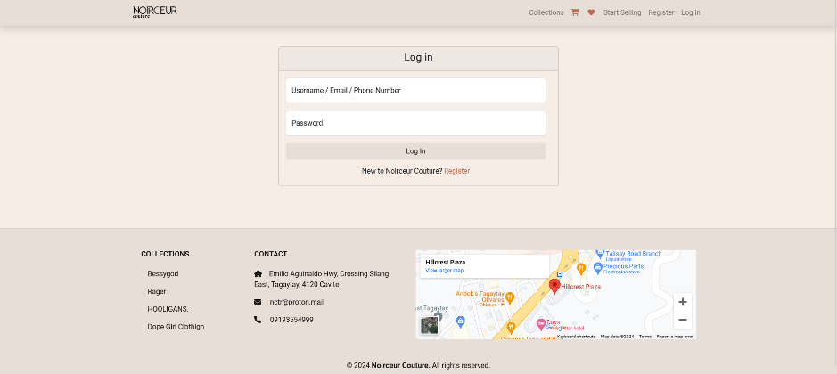

Figure 4 The Log-in page of the website.

**CART PAGE**: users can view their item they add to cart, delete item that they want and check out the remaining items.

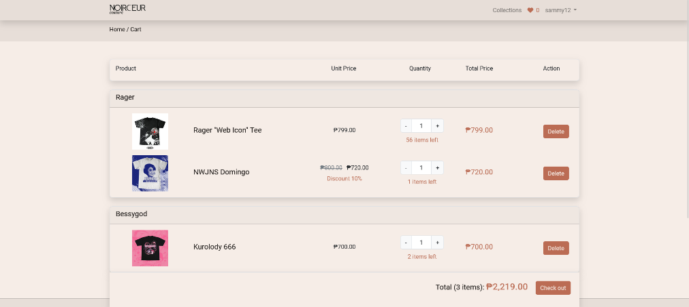

Figure 5 The Check out page of the website.

**My Likes PAGE**: users can view and delete their products that they like.

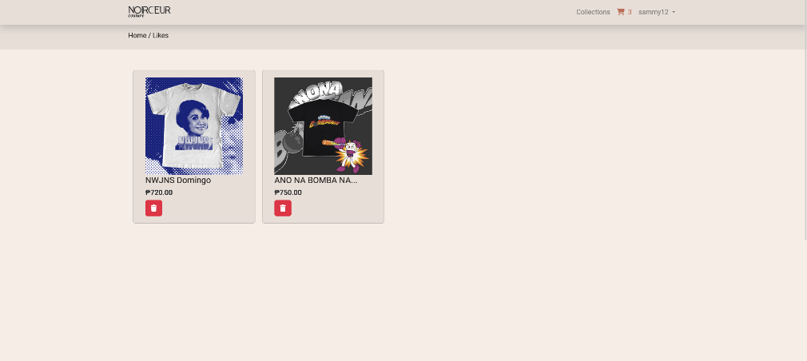

Figure 6 My likes page of the website.

**Check out PAGE**: users can place order their available items in their cart.

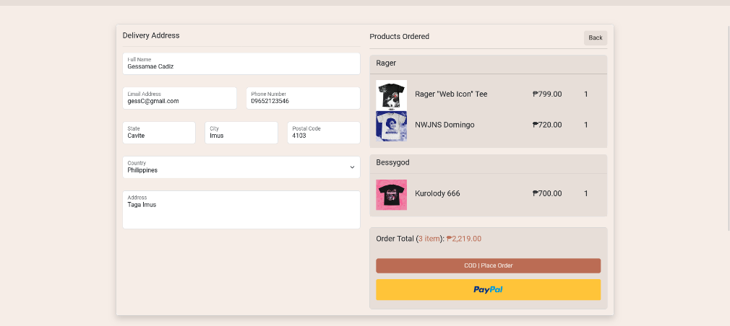

Figure 7 Check out page of the website.

**STORE PAGE**: Collection page that displays brand category names.

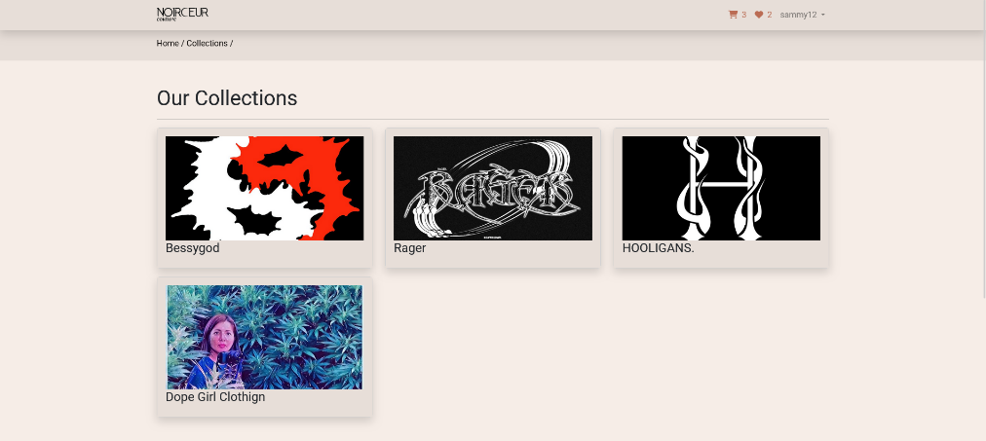

Figure 8 The Brand Collection page of the website.

**BRAND ITEMS PAGE**: Item page that displays brand items.

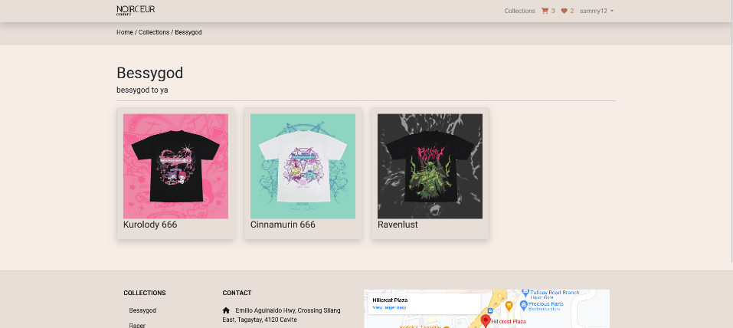

Figure 9 The Brand Item page of the website.

**BRAND Product PAGE**: Product page that displays details of product.

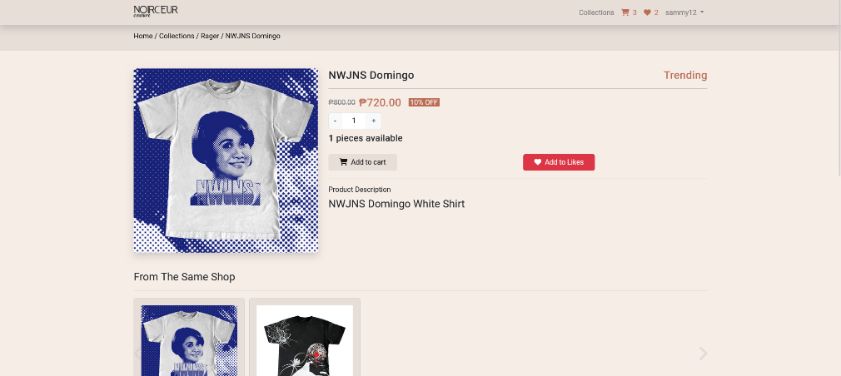

Figure 10 The Brand Product page of the website.

**ADMIN DASHBOARD PAGE**: Admin page that displays the products total quantity, expected revenue, total users, and total revenue from delivered items.

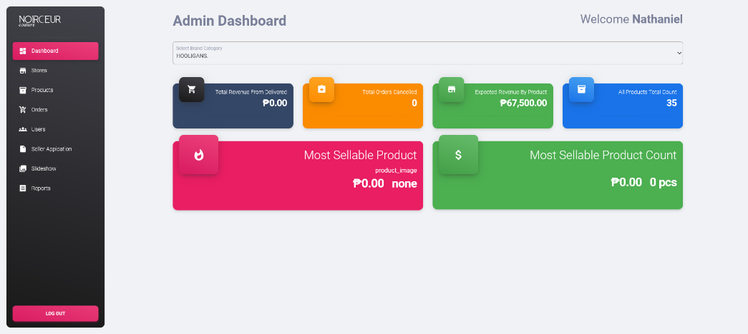

Figure 11 The Admin Dashboard page of the website.

**STORES**: Shows all the brand categories and admin can modify the details and delete brand.

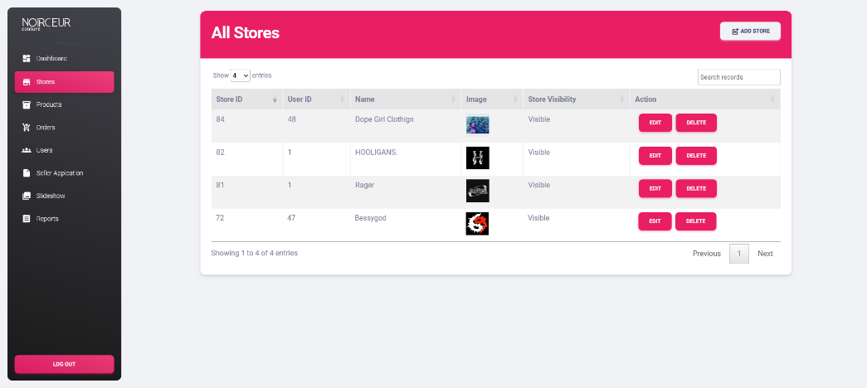

Figure 12 The Stores page of the website.

**ADD STORE**: This panel, admin can add a new brand.

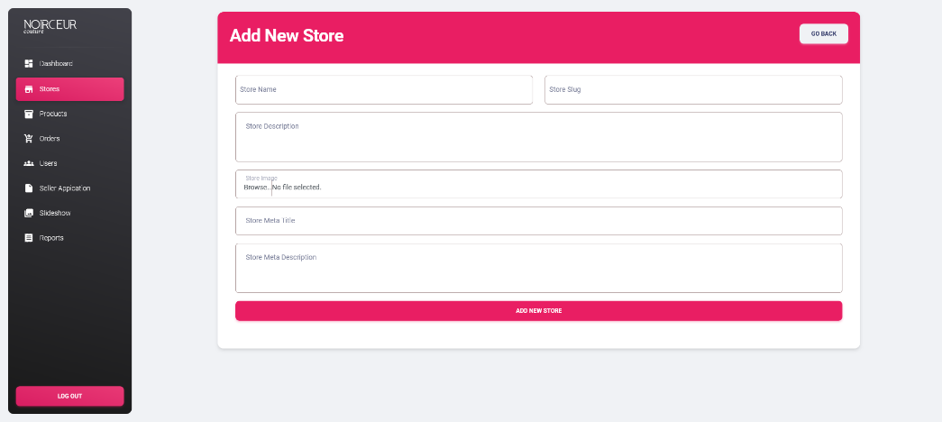

Figure 12 The STORE page of the website.

**PRODUCTS PAGE**: This panel, admin can view, modify, and delete all the items of products in any specific brands that are available.

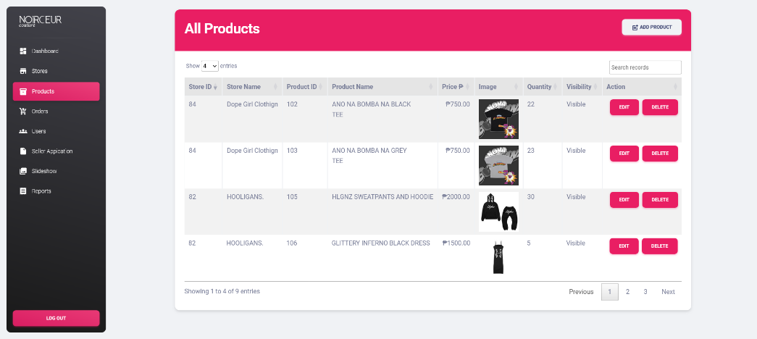

Figure 13 The All Products page of the website.

**ADD PRODUCT PAGE**: This panel, admin can add a new product in any specific brands that are available.

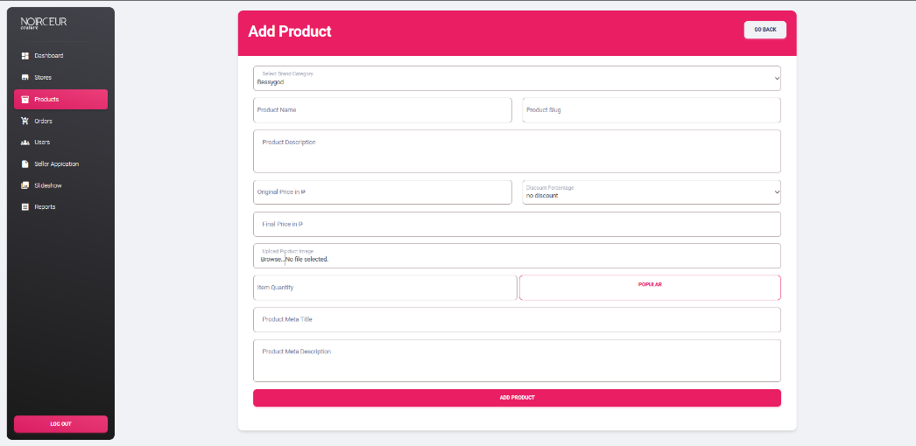

Figure 14 The Add Product page of the website.

**ORDERS PAGE**: This panel, admin can view all the order status of the user and change the parcel status from preparing to ship, parcel is out of delivery, parcel has been delivered, and parcel has been cancelled.

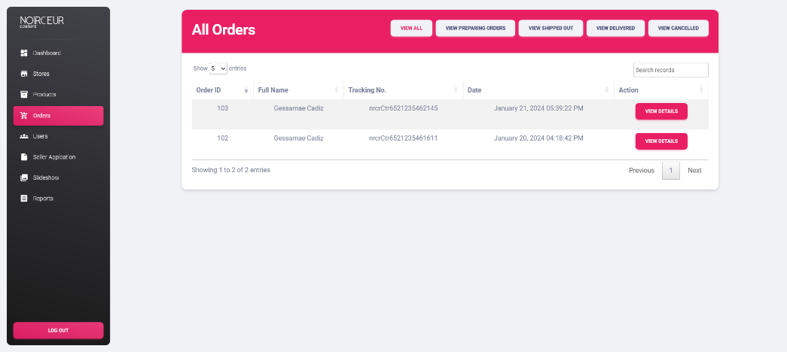

Figure 15 The Orders page of the website.

**USERS PAGE**: This panel, admin can view all the buyers and sellers and to modify.

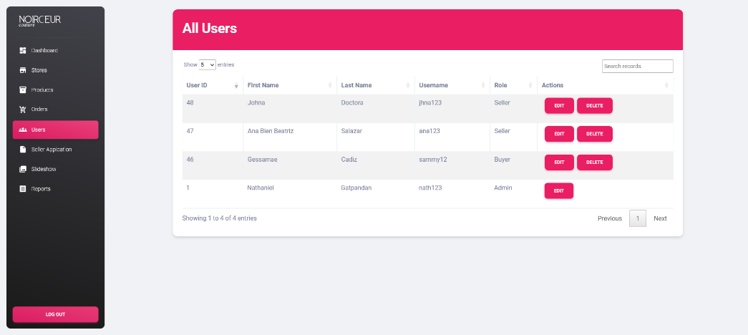

Figure 16 The Users page of the website.

**SELLER APPLICATION PAGE**: This panel, admin can accept and reject of the seller application.

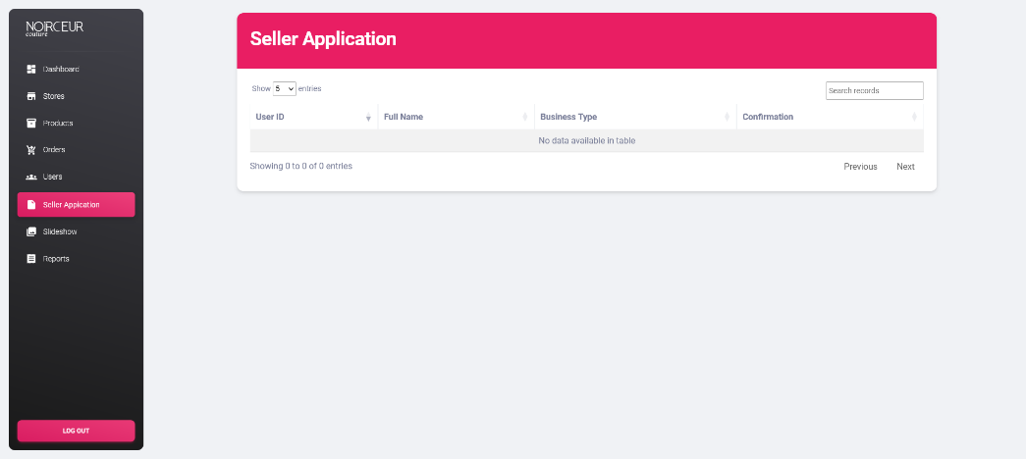

Figure 17 The Seller Application page of the website.

**SLIDESHOW PAGE**: This panel, admin can change the slideshow of the index.php.

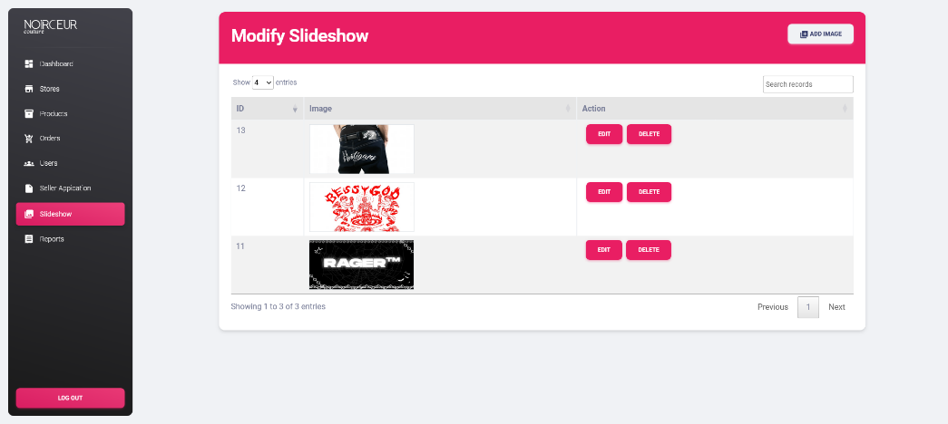

Figure 18 The Slideshow page of the website.

**REPORTS PAGE**: This panel, admin can print the revenue reports of their different stores.

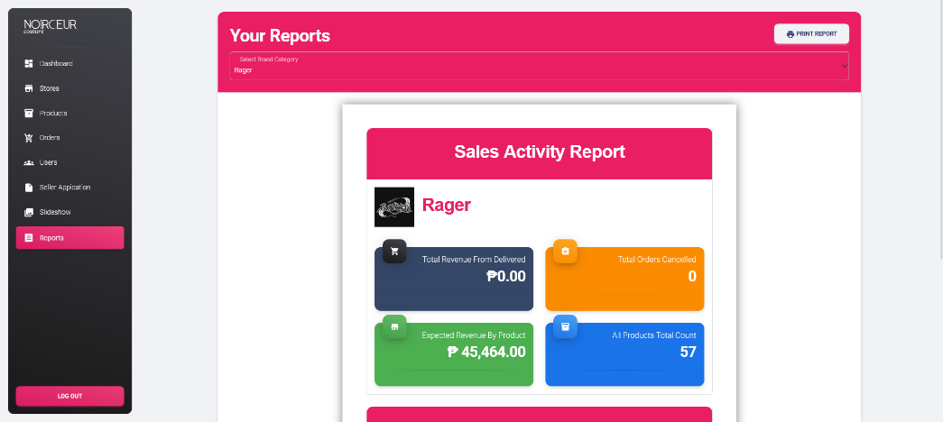

Figure 19 The Reports page of the website.

**ACCOUNT DETAILS PAGE**: This panel, seller can update login details and pickup address.

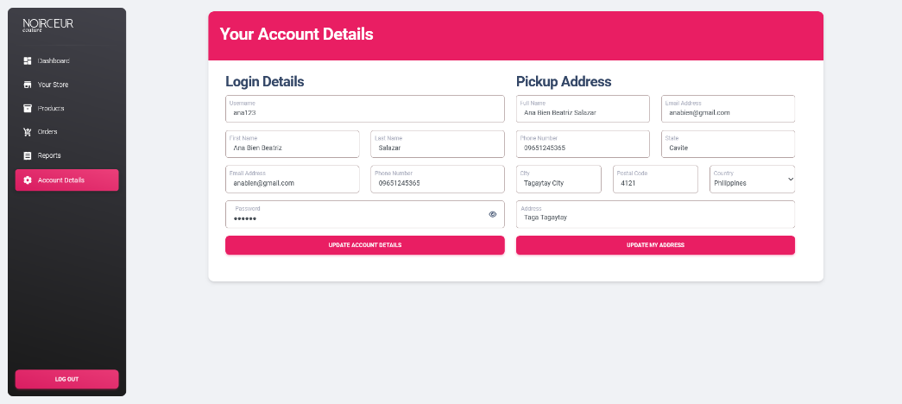

Figure 20 The Account Details page of the website.

**CONCLUSION**

In conclusion, effective documentation plays a crucial role in the success of an e-commerce business. Through this project proposal, we have identified the minimum document requirements necessary for the smooth functioning of an online retailer's operations. By addressing these requirements and implementing a comprehensive documentation plan, we aim to improve various aspects, including product details, legal compliance, customer support, and technical documentation. The establishment of an organized and user-friendly information framework will enable easy access to relevant information, enhancing efficiency and customer satisfaction. By incorporating consistent branding and recognition practices, we can foster transparency and strengthen the connection between buyers and sellers in the e-commerce ecosystem. Furthermore, the integration of suitable channels, such as websites and social media platforms, coupled with a reliable payment processor, will facilitate seamless transactions, providing a positive buying experience for customers. By undertaking this project, we strive to enhance the documentation process, streamline operations, and ultimately contribute to the growth and success of the online retailer's e-commerce endeavors. By embracing these improvements, the business can stay competitive in the ever-evolving digital landscape and deliver exceptional value to its customers.

**References**

Vatrapu, S. (2014). *Design and Implementation of E-Commerce Site for Online Shopping*. Govenors State University. <https://opus.govst.edu/cgi/viewcontent.cgi?article=1079&context=capstones>

Sharma Coder. (2022, February). *PHP ecommerce*. https://www.youtube.com/playlist?list=PL_99hMDlL4d0iIf0aji2kc4_e8VleaFw2